2.6.1 Box Model

Every HTML element you create can be seen as **a box**. Those boxes are composed of **margins, borders, paddings**, and the actual **content of the element** (e.g. text or an image). The figure below illustrates schematically how the box model of an HTML element looks like.

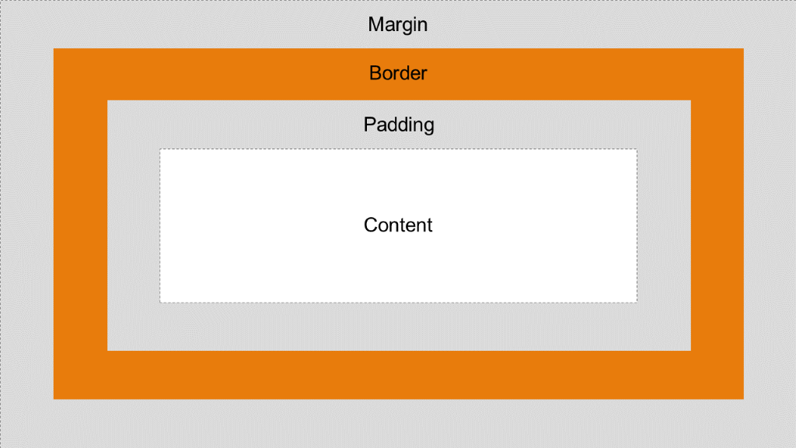

* **Content:** The element’s actual content area.
* **Padding:** The padding creates a gap between the element’s content and border. The element’s background color applies to the padding as well!
* **Border:** An element’s border wraps content and padding.
* **Margin:** The margin defines the area between an element’s border and the box of another element. An element’s background color does not apply to the margin!

Every part of the box model can be **manipulated using CSS**. Try it out!

1. You can address each side with separate property value pairs:

selector {

padding**-**top: 0px;

padding**-**right: 5px;

padding**-**bottom: 5px;

padding**-**left: 10px;

}

1. You can address each side separately with one **shorthand property:**

selector { padding: 0px 5px 5px 10px; }

In **this** **case** each value represents one side.

The order is **\*\***top**\*\***, **\*\***right**\*\***, **\*\***bottom**\*\***, and **\*\***left**\*\***.

<!DOCTYPE HTML>

<html>

  <head>

    <title>Cascading</title>

    <style>

        #element1 {

        background-color: rgb(69, 178, 157);

          padding: 25px;

          border: 1px solid black;

          margin: 25px;

        }

        #element2 {

        color: #ffffff;

          background-color: rgb(34, 34, 34);

          padding: 25px;

          border: 1px solid #000000;

          margin: 25px;

        }

    </style>

  </head>

  <body>

    <div id="element1">Here goes the content</div>

    <div id="element2">This is another element</div>

  </body>

</html>

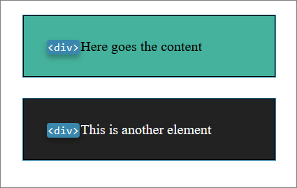

* The selector #element1 addresses the div with the corresponding id.
* The CSS property padding manipulates the blank space between content and border.
* The CSS property border takes three values. The first value defines the border’s width, the second value defines the border’s style (instead of solid, try dashed or dotted), and the third value defines the color of the border (try grey or #7BEE1D or rgb(238, 110, 115))
* The CSS property margin addresses the blank space outside the element’s border. Try other values between 0px and 25px. **Why does the gap to element2 not change for values between 0px and 25px but does change for values greater than 25px?**

The answer is that two margins of neighboring elements do not add up but overlap each other.**Only the biggest margin is the one determining the resulting gap**.

Box Sizing

In the last unit we’ve learned how to set the width and height of an element using the respective CSS properties width and height. However, it’s important to consider which parts of the box model are addressed with these properties – and which ones are not!

By default, both width and height refer **only to the content area** of an element.

**Padding, border, and margin are not taken into account**.

Hence, the <div></div> in the following example is not 300px wide**but 370px**!

<!DOCTYPE HTML>

<html>

  <head>

    <title>WidthAndHeight</title>

    <style>

        div {

          width: 300px;

          padding: 20px;

          border: 5px solid black;

          margin: 10px;

        }

    </style>

  </head>

  <body>

    <div>

      Hello world!

    </div>

  </body>

</html>

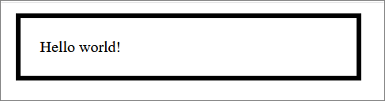

**And here is why:**

300px (width)

* 40px (padding left and right)
* 10px (border left and right)
* 20px (margin left and right) = 370px

So, what happens if you want an element to be 200px wide but you also want it to have a 2px border and a 10px padding? Right. You start with mental acrobatics subtracting pixles from your 200px width to make the result suiting your expectations.

**Fortunately, though there is another way:**

While the CSS command **box-sizing: content-box;** reflects the default setting (width and height **apply only to the content box**)

the command **box-sizing: border-box;** means that width and height take **content, padding and border (not margin) into account!**

<!DOCTYPE HTML>

<html>

  <head>

    <title>WidthAndHeight</title>

    <style>

        #upper-div, #lower-div {

          background-color: rgb(69, 178, 157);

          width: 300px;

          padding: 25px;

          border: 1px solid black;

          margin: 50px;

        }

        #lower-div {

**box-sizing: border-box;**

        }

    </style>

  </head>

  <body>

    <div id="upper-div">How is the weather?</div>

    <div id="lower-div">Could be better!</div>

  </body>

</html>

